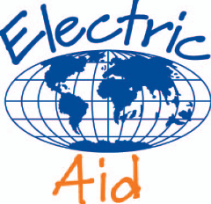 Project Reference No: 13-A-068

Final Project Report

Project Name: Strenthening Shelter in Khyber Pakhtunkhwa ( KP), Pakistan

Organisation Name: Trócaire

Date Funds Received: 31/07/2014

Referee:Corinne Voces , Institutional Funding Unit Programme Support Analyst

1: Projects Outcomes – the results achieved.

The aim of the project was to contribute to strengthening the Shelter ( Mera Ghar), specifically in the improvement of quality of services related to Gender Based Violence ( GBV) prevention and response. The existing Shelter did no longer offer enough capacity or resources for daily services. In order to cover for the diversity of needs of the survivors; legal, counselling, accommodation and medical, the project aimed at contracting a new renting lease for another building that will increase the capacity and the services offered by the centre. In addition, the project also envisaged providing appropriate accommodation and other basic needs to survivors and those who accompany them, often children under the age of five. The provision at the shelter of educational and recreational materials, as well as medical supplies, legal services and counselling will provide a comfortable and secure environment for survivors, offering a holistic approach for their particular circumstances, which encourages privacy and support to return to a normal life.

Please note that the following objectives include outcomes for both Noor Education Trust (NET) and Pakistan Village Development Program (PVDP) as result of the changes made in this project after its approval by ElectricAid Committee.

The key objectives of the project were:

- To strengthen GBV response services e.g shelter, medical aid, legal aid, legal and psycho-social counselling in order to provide GBV survivors with improved quality response services.

SHELTER

In order to provide better care, protection, boarding and lodging to the survivors, NET moved premises to another location, which now provides additional space and more allocated spaces for different activities, as well as privacy for counseling, medical or psychological interventions. Shelter Mera Ghar , has now separate rooms for psychological interventions; one for treatment and also a waiting area, allowing survivors and their children to have a private space to express their views and concerns with the psychologist, without feeling anxious or uncomfortable of speaking openly when there are other patients in the room. In addition, therapies are much more effective as privacy promotes openness, thus quicker assessments. Before this project, the shelter had only 3 rooms and could accommodate 7 to 10 people at a time; the new premises have a total of 7 rooms, which allows it to accommodate comfortably 15-20 people at a time.

During June 2013 to May 2014 a total of 126 survivors accessed shelter. 12 GBV cases have been referred by pro bono lawyers, whereas 18 cases have been refereed by community vigilant groups. Similarly 48 GBV survivors were referred through information desk officers (IDOs) at the local hospital. Among these, 96 cases (66 girls and 30 women) benefited from shelter support and 30 cases have been registered only for free legal aid services.
To date 57 individual counselling sessions have been conducted, along with one outdoor group session. In addition, 96 individual legal counselling sessions have also been conducted.

Other referral partners have also started to use the space to counsel the GBV survivors and children such as, the United Nations High Commissioner for Refugees (UNHCR) to meet/interview the GBV survivors and children on regular basis.

The Women Wellfare Centres (WWCs) in the villages of Teerat and Shangai run by PVDP have also improved their psycho-social counselling services. A separate room has been allocated at each centre with the necessary furniture; tables and chairs. Psycho-social counselling sessions focuses in the provision of individual specialised care by applying psychological counselling techniques and therapies for resolving disorders, such as anxiety or depression.

The WWCs provided services to 173 women and girls from Swat during the period. Seventy survivors received vocational and skills training, 20 received counselling, 39 women completed basic adult literacy courses and 44 completed basic computer courses focusing basic computing skills

Both NET and PVDP provide in-house awareness sessions to registered GBV survivors in Shelter and WWCs. Twenty four awareness raising sessions on women socio legal rights, pro women legislations, and existing legal response systems were organized. All women have now improved their knowledge on types GBV, women legal rights and supporting systems in the country. Through these in house awareness sessions, many survivors felt encouraged to share their issues in privacy and receive individual counselling sessions in WWCs. In addition, 18 women survivors approached WWCs psycho-social counselling (PSC).

Due ongoing conflict in Pakistan, energy supply is unreliable especially in district of Swat, in fact in recent months power cuts could last 8 to 10 hours. Now, both WWCs have a complementary solar power supply that can support uninterrupted power supply for all activities in the centres. NET has also installed a heavy voltage UPS (uninterrupted power supply) system to avoid disruptions in activities

BASIC MEDICAL FACILITY

Prior to this project, the shelter dint have an adequate medical facility or equipment to support the immediate needs of GBV survivors. Whenever a survivor and/or children accompanying them needed to have medical assistance, the shelter team facilitated treatments at the nearest health facility in the area. However, this created distress in the patient, as she would feel vulnerable to other security risks.

Since the medical facility was upgraded with specialised equipments, such as blood pressure monitor, nebulizer machine, oxygen masks, patient stool and stretcher etc, the volunteer doctor can now treat all patients on site for infections, first aid support as well as other minor ailments. Patients feel less anxious because they are treated in the shelter premises and by the same doctor. In addition, they can rest in the new beds, so they can recover quicker and more comfortably. To date, 56 women and children survivors have benefited from the medical facility.

PVDP has also established basic medical facilities in both WWCs. The medical facilities are fully equipped with basic medical equipments and supplies. The provision of a female medical officer for both centers has proven difficult due to the shortage of staff and resources from the district hospital, however since September a female visiting doctor has been confirmed ,and has started visiting the WWC regularly. During the period, 8 survivors were provided with free medicines prescribed by the doctor from district hospital. In case of emergency, the team also facilitated 2 survivors in visiting district hospitals.

- Contribute to gaining new skills and economic empowerment for survivors accessing Women Welfare Centres (WWC), through the provision of equipment and material for technical/vocational trainings

BASIC COMPUTER LEARNING (BCL)

Both Teerat and Shagai WWCs are now equipped with 6 laptops on each centre that support increasing computing literacy the centres. Initially the project proposal included 6 laptops for one WWC, however just as to cover the increased demand 6 more laptops were purchased for the second WWC.
67 individuals, 25 women and 42 girls have enrolled BCL courses; however, as there are only 6 computers per centre, to date 44 women and girls have completed the course. The encouraging factor is that more school girls are taking more interest in attending these courses, so the centres intention is to continue increasing the capacity and resources of the centres, so BCL courses continue in the future.

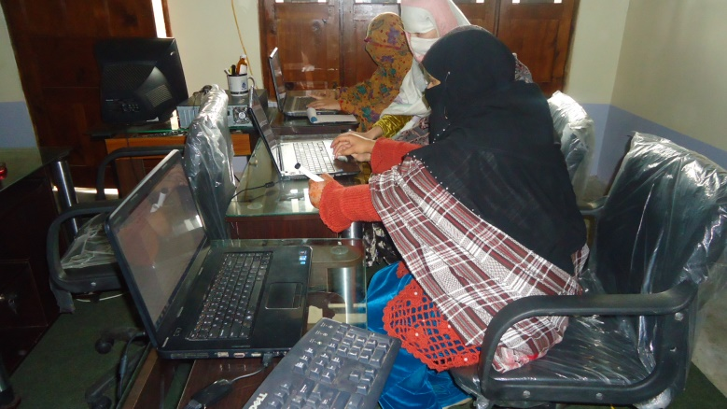
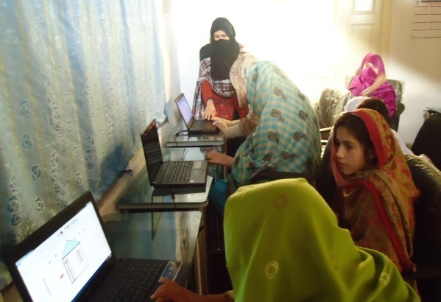
Picture 1 Basic Computer Literacy Group at-WWC Teerat and Picture 2 at WWC Shagai

VOCATIONAL SKILL TRAININGS

The group of women in WWCs have shown a great interest in vocational trainings , at the end of 2013 70 people, 23 women and 47 girls signed up for vocational trainings such as basic skills on making clothes, sewing, embroidery , netting and ribbon making techniques. With the new allocated facilities for training there is a growing demand for these trainings. Currently 10-15 participants can be taken at a time. At the shelter also 30 women have completed their vocational training. In addition; some survivors are now using their newly gained skills to teach others in the centres. One survivor is supporting adult literacy in the shelter after learning within the premises. Two survivors are employed as vocational trainers in NET.

As result of these various trainings, about 20 girls at the WWCs are already using their newly gained skills and they are stitching clothes for family members, which is both resulting in a family saving for them but also a new source of income.

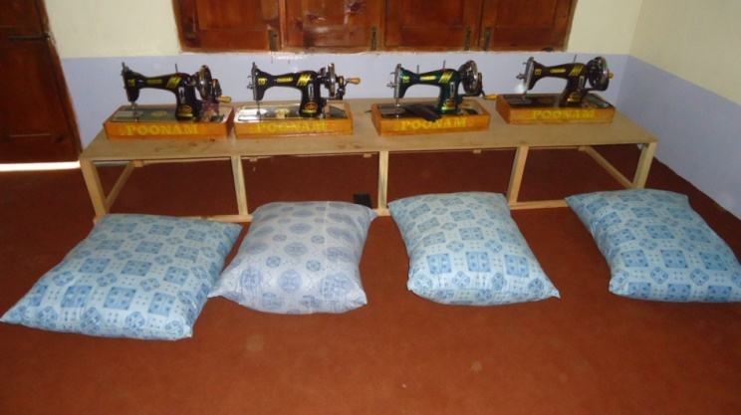
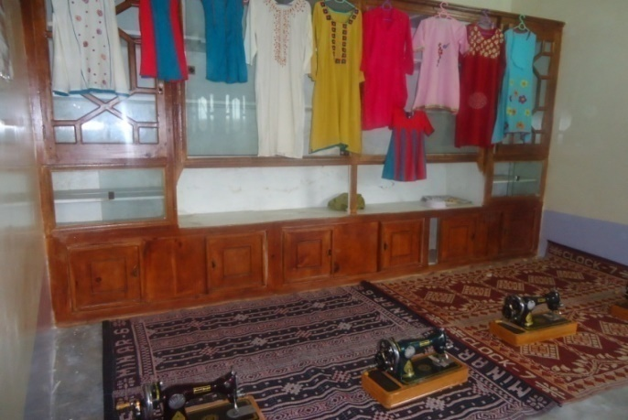
Picture 3 &4 of the sewing machines and some of the clothes made in the WWCs . Girls’ Group of Batch II on stitching in WWC – Teerat commented: “Previously, we had to wait to save money to get just one dress stitched from the dressmakers. Now, we don’t need to give our dresses to the dressmakers, we can do it ourselves but also for our extended families and friends. We can now save money as well as earn some’’

- Become a reliable, secure environment for GBV survivor’s in the province, while supporting the creation of the second government run shelter of these characteristics in the province. At the same time encouraging awareness of legal right among women and promoting legal systems in Pakistan that would lead to stronger enforcement.

In many cases public services address issues faced by survivors in isolation, for example health or legal matters, however this leaves other problems unaddressed, such as safe accommodation and dealing with emotional issues, while their situation is being addressed. The existing Shelter (Mera Ghar) has been strengthening the links with other institutions as to extend the impact of interventions, as well as increasing awareness within communities of services available to GBV survivors. Linking with other institutions reinforces the understanding of protection laws and Constitutional rights in Pakistan among communities, this is often most important in rural areas as there is often little of no knowledge of supporting services or legal rights.
NET has been linking with Local Police, Medical and Legal officers as well with the shelter run by the government (Dar-ul-aman) on awareness training and community understanding on GBV issues. Together they are looking at strengthening their role for supporting GBV survivors and lobbying with government to strengthening existing support services for women. NET has also established a referral mechanism between NET and, shelter Dar-ul-aman and District health and Police departments for cases that require immediate protection. In addition, there are desk officers in three major district hospitals who identify cases and offer advice and further intervention measures to GBV cases.
Similarly, cases received at WWCs that require legal or medical services, are being referred to NET. PVDP has referred 3 survivors to NET for shelter and legal aid services.

- To ensure standard security systems at the shelter for proper protection of all GBV survivors accessing the response services.

With the upgraded security system, gate keepers and shelter managers are now able to check on the entry points and its surroundings before opening the gate to visitors, in addition to extra security overnight as result of higher walls and new wiring. The upgrade of the security system initially resulted in some discomfort by some of the community members and as result some of the security systems were purchased, and installed in two stages both at the shelter and at the WWCs:

Shelter has installed 4 security cameras, 1 video recorder, wall fencing and wires As well as 4 emergency lights and security alarms.

WWCs have installed the emergency lights in the centres. The security cameras and the video recorders were not installed because the community, despite ongoing communication, have not accepted their presence, as it affects the privacy and the seclusion of women from public observation, which is traditional in Muslim culture. As result PVDP and Trócaire agreed that the security cameras and the video recorders were to be installed at PVDP field office in Swat as serious security issues continue in the region. Providing any community supporting services in the region of Swat entails security risks both for social workers and visitors, PVDP staff at Union Council Madian of District Swat put their lives at risk in order to carry on with daily work , their office is often visited by beneficiaries looking for support and other stakeholders .The presence of Taliban groups in the area often present security issues for all community members . The case of Malala Yousafzai, in this region, is widely known internationally and she remains an advocate for freedom and education.
Both NET and PVDP early engagement with both community members and the survivors from early project implementation has helped to introduce and install the security systems in these communities. Even with some delays, to date the introduction of the security systems has helped to solve some issues, for example, one person was identified through surveillance cameras and was reported to the police and staff in the shelter.

- To ensure basic educational and recreational facilities for GBV survivors (under 15) as well as for children (under 5) accompanying survivors.

As to support children’ ongoing education, Shelter Mera Ghar now has a kindergarten facility for children from 3 to 12 years, with a primary school teacher five days a week. Through the provision of new learning material, children have been able to learn the alphabet, numbers and simple arithmetic problems, as well as simple sentences in English and Urdu. They also learn new skills in kindergarten, such as write their names or basic sanitation skills.

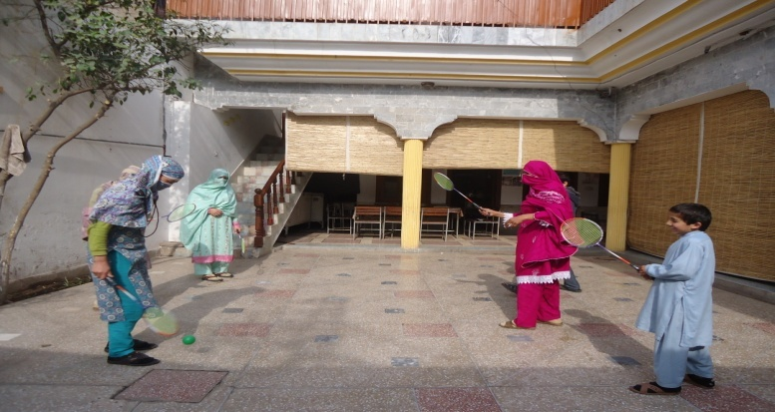
Through recreational activities, survivors can interact and participate with others in a non intrusive way, thus also supporting their integration in the group. Both the WWCs and Shelter Mera Ghar , have now toys that helps mother and children to enjoy time together, while also engaging with other survivors. Some of the toys include; swings, trampoline, kid’s slides, cricket and football items and other games, which gave children an opportunity to exercise and have fun. At the same time, mothers were also able to join courses for physical fitness that supported their well being, confidence and relaxation.

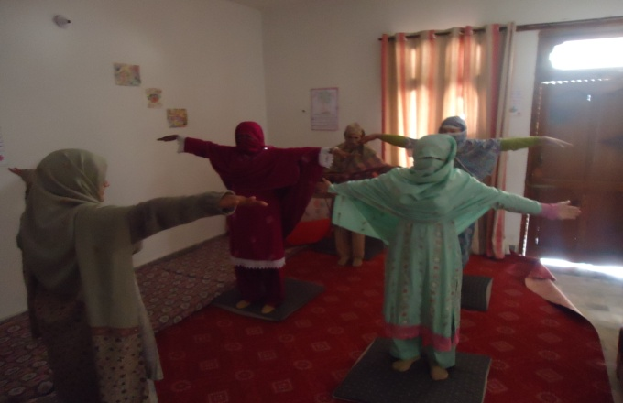
Picture 5 & 6. Survivors and children enjoying recreational facilities at Shelter Mera Ghar.

Basic educational material has also been developed at the shelter and WWCs, brochures, leaflets, booklets have been utilized in awareness sessions. More educational posters have been printed recently which adds to the educational materials already available for distribution.

Many of the survivors that come to the WWC have very little skills, through the basic adult literacy programme ,they can improve their reading and writing skills, thus be able to be a bit more independent, for example by being able to do the shopping on their own. The course is composed of basic counting, identification of English and Urdu alphabets, with basic identification and formation of words. To date, 39 individuals at the WWCs, 16 women and 23 girls have benefited from the basic adult literacy programme. Also, 46 women and 19 girls at the shelter have completed the programme.

2: Financial Accountability – how the money was spent.

Updated Sept 2014
 |  |  |  |  | Covered by
1 | PERSONNEL |  |  | Euro Budgeted | Irish Aid | ElectricAid | NET/PVDP | Expenditure
1.1 | 2 Legal officers |  |  | € 15,000 | € 7,500. |  | €7,500. | € 15,000
1.2 | 1 Medical Officer |  |  | € 1,406 | € 1,406.00 |  |  | € 1,406
1.3 | 2 Phychologists |  |  | € 13,125 | € 6,563 |  | € 6,562 | € 13,125
1.4 | 1 Teacher and 2 care takers for children ( volunteer) |  |  | € 2,063 |  |  | € 2,062.00 | € 2,063
1.5 | Other programme costs ( Monitoring , coordinator, admin |  |  | € 7,031 | € 7,031.00 |  |  | € 7,031
 | Sub-total |  |  | € 38,625 | € 22,500 | € - | € 16,124 | € 38,625
2 | ADMINISTRATION COSTS
2.1 | Shelters rent |  |  | € 3,750 | € 3,750 |  |  | € 3,750
2.2 | Running costs( phone, internet,courier,stationery) |  |  | € 2,813 | € 2,813 |  |  | € 2,813
2.3 | Rent & Vehicle runing costs (court hearing, medical) |  |  | € 3,750 | € 3,750 |  |  | € 3,750
2.4 | Monitoring , evaluation and capacity building |  |  | € 2,305 | € 2,305 |  |  | € 2,305
2.5 | Medical costs for survivors |  |  | € 469 | € 469 |  |  | € 469
2.6 | Capacity development of shelter team and survivors |  |  | € 1,289 | € 1,289 |  |  | € 1,289
 | Sub-total |  |  | € 14,376 | € 14,376 | € - | € - | € 14,376
3 | LEGAL COSTS
3.1 | Court and legal expenses |  |  | € 2,344 | € 2,344 |  |  | € 2,344
3.2 | Mobility costs, meetings, referrals and services |  |  | € 2,031 | € 2,031 |  |  | € 2,031
 | Sub-total |  |  | € 4,375 | € 4,375 | € - | € - | € 4,375
4 | PROVISION OF BASIC EQUIPMENT & TRAINING
4.1 | Security system ( NET: 1 video recorder, 4 emergency lights, 2 alarms, PVDP: 2 video recorders, 2 emergency lights ) (NET: 4 Security cameras and wires for fencing, PVDP: 4 security cameras) |  |  | € 2,788 |  | € 2,788. |  | € 2,788
4.2 | Labour costs for security systems NET only |  |  | € 391 |  | €391 |  | € 386
4.3 | Furniture for medical, counseling and literacy centre( chairs, stools, tables, examination table |  |  | € 1,767 |  | € 1,766 |  | € 1,774
4.4 | Basic medical equipment ( 1 first aid kits, gloves, masks, oxygen masks, scales, nebulizer, small fridge, HIV test kits) |  |  | € 1,149 |  | € 1,149 |  | € 1,239
4.5 | 8 Standard single beds , side tables and bed linen. NET only |  |  | € 1,367 |  | € 1,367 |  | € 1,366
4.6 | Extra furniture for shelters( visitors dinnning, literacy centre and 8 computer desks) |  |  | € 2,313 |  | € 2,313 |  | € 3,146
4.7 | 6 Computers . PVDP only |  |  | € 2,813 |  | € 2,813 |  | € 4,218
4.8 | Heating/Cooling systems ( NET 2 Air conditioners, 4 heaters) (PVDP 6 Celing fans and 6 butane gas cylinders and stoves) |  |  | € 1,493 |  | € 1,493 |  | € 1,492
4.9 | Installation and maintenance of supplementary power supply |  |  | € 1,563 |  | € 1,563 |  | € 1,558
4.10 | Educational tools for play centre and for GBV survivors and children. NET only |  |  | € 860 |  | € 860 |  | € 860
4.11 | Material and Equipments (6 Sewing and 2 embroidery machines each and raw material) for Vocational Trainings for GBV survivors. PVDP only |  |  | € 1,250 |  | € 1,250 |  | € 1,250
4.12 | Development of IEC materials for GBV survivors |  |  | € 1,433 |  | € 1,433 |  | € 2,734
4.13 | Training for GBV survivors .NET only |  |  | € 625 | € 625 |  |  | €625
 | Sub-total |  |  | € 19,812 | € 625 | € 19,185 | € - | € 23,439
 | Overall totals |  |  | € 77,188 | € 41,876 | € 19,185 | € 16,124 | € 79,694

Please note: As result of the changes in funding requirements from partner NET after the approval of the application by ElectricAid , the overall cost of the materials for the shelter were reduced from the original budget . As result, the amount initially allocated from Irish Aid to cover the cost of this project has been used to cover the overspends in some of the budget lines, in addition to other activities, such as the additional 6 laptops for one of the WWC. Also, this budget has included the allocated cost to partner PVDP, thus in some of the lines the Euro budgeted and the expenditure columns include both partners.

3: Project Process Narrative – how the project was implemented or progressed to date.

Project Aim: The project aim was to strengthen the number and quality of services of Shelter Mera Ghar and two WWC as to enable a safe environment, which leads to the full rehabilitation and self-fulfilment of survivors of GBV in the selected districts Noshehra,Swabi Swat and Mardan of the KP province.

Project Evaluation:

The feelings and emotions of the survivors are listened with love and respect, taking ample time to access, analyze and evaluate the petitioner’s opinion. It is both NET and PVDP approach to instruct survivors with regard to all options available, before any legal steps are taken
NET/ PVDP have a firm belief that it is essential to create a culture of awareness of the law among vulnerable groups, so they can familiarize themselves with the scope of their rights, and eventually assert women rights in society.
In most cases the centers/shelters are used as a “Well Being” service, going into every detail with its legal and social implications, as well with their most basic needs such as accommodation, medical care or training. New equipment has allowed for a more personalized care for the survivors; counseling, accommodation, medical, legal aid as well as support their vocational trainings. Multiple activities can now take place on the same premises, this is especially important for survivors that feel unsecured and frightened, as it creates and environment where they can feel safe and taken care of. In turn, it supports their successful reintegration in society through the use of holistic rehabilitation initiatives. Designated areas have also created more opportunities to talk with survivors and children without partners, family members or friends being present. Children have also designated areas where they can play or continue their education without disruptions.

As a result of the counseling sessions, a positive behavior change was observed among the survivors .For example one of the survivors left her home temporary due domestic violence. Through counseling and the help of the psychologist she has gained a better understanding of the situation and discus openly her issues; she has also learnt how to do stitching, so she can now support the economy of her family. Mediation and counseling has also allowed her to come back home.
Furthermore, the increased capacity and resources of the shelter and WWCs has helped other survivors to express an interest in the services given, through the provision of vocational trainings they are learning to trust staff and these type of services, so if needed in the future they can also avail other services. It has been also noted that women feel it has open a platform that empowers them to openly discuss and share their opinions with others in similar situations, thus also increasing the sense of community discussion and integration. Women have also said that they feel comfortable and happy in the premises and also break their daily routines.

Results Reported:

This project has enabled both Shelter Mera Ghar and the WWCs to increase the impact of their activities on women survivors and their children. With the added resources, staff can now have the tools to increase awareness and understanding of GBV issues in these communities. In many cases rural women suffer their problems in silence with the fear of sharing experiences in case their situation worsens. Provision of basic facilities allows women and girls to have a safe space for their rehabilitation and reintegration in society. In addition, the project has also increased opportunities to cover the limited health and educational services in the area, GBV survivors now have more reasons to approach a variety of services in a secure and comfortable environment. This has also allowed increasing the engagement with community members who were discontented with the presence of WWC or the shelter in their communities; they have also now gained awareness, and the activities of the centre are slowly being accepted in the communities.

Overall Shelter Mera Ghar has benefited from:

- New Shelter premises, with 7 rooms can accommodate 15-20 survivors at one time and enables to have specific rooms for different activities and therapies. The numbers of survivors accessing the shelter have doubled from the previous year, from 63 in 2012 to 126 from May 2013 to June 2014
- Basic medical equipment for survivors and children ( first aid kits, gloves, masks oxygen masks,scales, nebuliser, small fridge, HIV test kits) as well as dedicated furniture for counselling/ psychological and medical interventions ( chairs, stools, examination table)
- Extra furniture for shelter ; for visitors and dining area, including 15 standard single beds and side tables bed linen and 2 air conditioners and 4 heaters.
- Improved security systems.1 video recorder,4 security cameras and wires for fencing, 4 emergency lights and 2 security alarms were installed
- New supplementary uninterrupted power supply system that covers the electricity needs during power cuts
- Allocated teacher and kindergarten area for children (3-12 years) along with accessories for educational and recreational purposes.
- New educational tools have been purchased as well as other materials to support adult education. Brochures, leaflets related to general awareness on basic rights and GBV services have been printed

WWC have also benefited from:

- The number of survivors accessing WWC have increased from 66 in 2012 to 173
- Resources for vocational trainings have been purchased, to date 70 survivors have received vocational trainings and through the use of 6 sewing and 2 embroidery machines some trainees have started to produce their own income.
- Adult basic training courses and 12 new computers for computing skills with computer desks, to date 37 women and girls have completed basic computer learning courses.
- Basic medical equipment for survivors and children ( first aid kits, gloves, masks oxygen masks, scales, nebuliser, small fridge, HIV test kits) as well as dedicated furniture for counselling/ psychological , medical interventions and literacy centre ( chairs, stools, examination table).
- Improve security systems. 2 emergency lights, 4 security cameras and 2 video recorders have been purchased.
- New supplementary solar power supply that covers the needs of the centre when there is power cuts.
- Educational material has been developed as to support awareness on GBV issues

Update Sept 2014

All the security items have been installed at Shelter Mera Ghar , the community and survivors have accepted the presence of the security items. PVDP has installed new security cameras at the PVDP office in Madian, staff has expressed their gratitude, as this bring extra security to the premises.
The purchase of 6 ceiling fans and 6 gas cylinders and stoves has been completed. Mild weather conditions have allowed for a delay in purchasing the equipment, but now both staff and survivors will have added comfort in the WWC
PVDP has also arrange for a visiting female doctor to work at the medical facility at both WWC, with pick and drop service to each WWC for the doctor along with consultation fee that will be covered by PVDP

Additional brochures and leaflets related to raising awareness on GBV services and basic human rights have been printed and distributed to new survivors and also those already registered both at the shelter and the WWC.

Challenges Faced:

As to ensure the most appropriate services and security for the survivors, the selected rented premises must be within close proximity to public health facilities and other public institutions such as solicitors’ offices and police stations. This allows easier reach and also creates links with other institutions, thus extending the supporting services that the shelter/WWCs can provide. However, finding the premises that covers all the necessary conditions is becoming more difficult with the continued security situation in the province of Khyber Pakhtoonkhwa (KP) and in Swat district in particular. At the same time due to lack of similar basic services in terms of shelter, rehabilitation and reintegration and even vocational centres in the area, both WWC and the shelter have experienced an increased demand for their services, which challenges their limited resources.

Nevertheless even with these challenges and based on the increasing numbers of people in need of support , NET is aiming at strengthen the future of the Shelter Mera Ghar, by looking at securing funding to purchase a plot of land in Peshawar, so in the future they can build their own premises

The acceptance of the introduction of the security systems has also been one of the major challenges for both WWC and the shelter. Due to the strict Purdah rigid culture (veil that conceal women face), concerns were shown by women and girls in the shelter and the WWCs, but also by male members of their families. The acceptance of the security cameras continues to be slow and this is more noticeable in rural areas, as traditional views seem to be more widespread and difficult to change. Shelter Mera Ghar is located in Peshawer, which is provincial capital of KP province where people are more educated and familiar with the purpose of security systems. As result the survivors at the shelter have accepted better the presence of security systems and now feel safer while in the shelter.

Impact:

Due to the lack of adequate basic services for these rural communities such as phycho-social , medical or shelter services, survivors often felt they had no option than remain in silence about their issues. Through this project and the additional services supported by Electricaid, the project has been able to create an impact in both the gap in basic services in the area, as well in the provision of a centralised space to accommodate better for all the particular needs of the survivors and their accompanying children. The renovated premises provide a safe and comfortable environment for survivors, so they can feel more empowered to learn, openly discuss and address their issues. In addition, it has created new spaces for communication between staff and survivors, which also promotes awareness raising of basic human rights, as well as supporting their educational and vocational needs. Women now are more open to trust and discuss issues when they understand the services provided, more so, through the extension of vocational courses, both the shelter and WWCs, have been able to increase their impact in these communities. Promoting women’s rights among the survivors and their communities, increases community dialogue and understanding, thus, challenging the overall conservative views of women roles in the political, economic and social sphere of society.
The objective of this project was to fully capacitate both shelter and WWCs to cater the longer term needs of GBV survivors through a holistic rehabilitation mechanism .Women can now fully benefit from these improvements by feeling more empowered and equipped with required skills for successful reintegration.

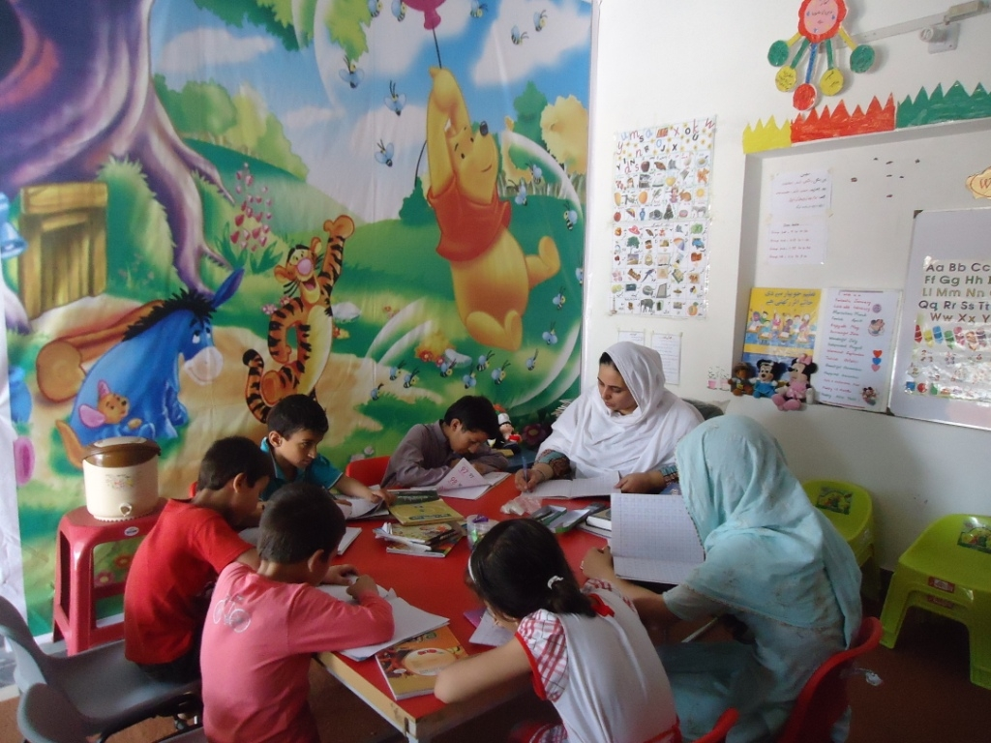

Picture 7 Children at learning class at Shelter Mera Ghar

Case study

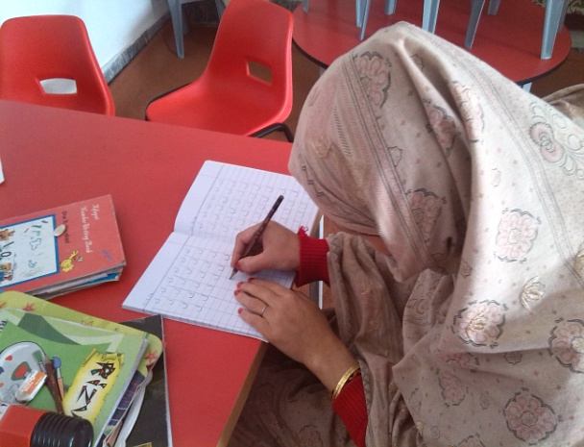
In August, 2013 Ms. S, 25 years old, from Peshawar, approached NET for shelter protection, legal aid and psychosocial support. She is married to an old person and at the time had a disagreement with her husband and her father. When she arrived at the shelter she was not able to speak in Urdu and she used thumb fingerprint as a signature where document signature was required. During her stay at Mera Ghar she took part of the formal and informal education, as result she has learnt to speak Urdu in adult’s class as well as other basic skills. She also availed reconciliation services at the shelter to solve the issues with her family. She can now sign all the documents instead of using her thumb. Her conflict was mutually resolved.

http://www.biography.com/people/malala-yousafzai-21362253#after-the-attack

