Electric Aid Challenge 2015

What is the Electric Aid Challenge?
An opportunity to get innovative and creative to support the work that Electric Aid is committed to. Each year Electric Aid works hard to raise funds to continue support those who need it most, both in Ireland and overseas. Through very simple acts we can all play a part in supporting those efforts. So this year, we would like to put your creative juices to the test and to set yourself a personal challenge/goal and get behind the work of Electric Aid in ESB.
- Is there something you’ve been thinking about doing, but haven’t gotten around too?
- Have you got an idea to rival the Ice Bucket Challenge of 2014?
- Is there a target in your mindseye and you’re looking for that push of motivation to get you there?
To see where your effort will have impact check out Electric Aid.ie for regular updates on how we are making a difference http://www.electricaid.ie/
Who’s running it?
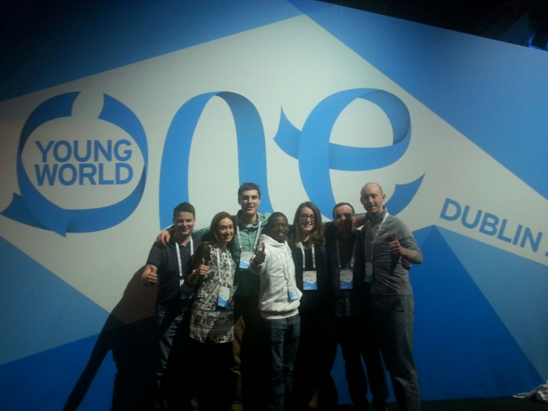
Last year a small group of ESB employees from across the business had the opportunity to attend a global summit for young leaders called One Young World (see more here at www.oneyoungworld.com ) The focus was on the need for change. Change for the better of our world, and the central message of the summit was that no matter how small the change, there was unlimited potential for its impact.
Sean, Cormac, Lisa and Clodagh put their heads together after the summit to see where that call to action could be answered in ESB. How can we tap into the ideas and energy already in ESB for positive change? We have focused our efforts on getting people to think differently, getting people involved and The Electric Aid Challenge is our way to start that momentum. We were so inspired by the creative ideas from young leaders from all over the world at the summit, we are hoping to see some great ideas coming through from ESB too.

Ok, sounds good – how do I get involved?
We will be making use of ESB’s internal social media forum, Yammer for this challenge. It’s a space to share ideas, join others who are working on something exciting and celebrate successes of goals reached. Log on to the Electric Aid Challenge page to let us know your ideas and how we can support you to get started. From there you can check in through Yammer with the highs and lows of your own challenge and keep in touch with teams and individuals who are also working their own challenge.
We’re looking forward to seeing the progress and updates. You can access it through your smart phone or log on through your work PC with your ESB email address, www.yammer.com . Let’s get Yammering for positive change!

What sort of fundraising activities are suitable?
There’s no limit or restrictions on what you can do! The traditional activities for raising funds are great, but why not test yourself to do something new that hasn’t been done before? We want to share your story on Yammer and get others behind you, so the more creative and different the better. Can you be the next person to convince the world that throwing a bucket of ice water over their heads is a great way to raise some funds? Go on, try something out and see where you take it!

How do I raise money?
On the Electric Aid Yammer site, there is a link to the challenges’ sponsor card. You can print this out or keep it on your desktop. It can help you keep track of those that are supporting you.
You don’t have to publicly say how much you raised if you’d prefer not to, the final amount is not our focus – its about showing others how any small act can have impact and inspire others to get thinking about what they can do. So use Yammer to share pictures, updates and get support from others.

Make it social!
So you have an idea but you’re not sure if you can get there alone, or have the time to commit fully? Reach out to others get support and bring energy and ideas from your colleagues in ESB. We want to make this challenge social by using Yammer to share and bring ideas and people together from across the ESB business. A great opportunity to collaborate and of course make connections.

Still got questions?
Please get in touch with us at electricaidchallenge@esb.ie with any questions.

