
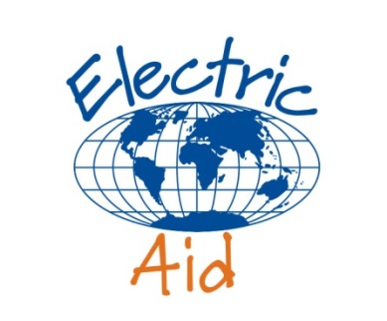

Final report on rebuilding livelihoods in Haiti

Electric Aid Ref: 16-A-136
Prepared by ActionAid Haiti and ActionAid Ireland

1. Rationale and Background
Hurricane Matthew struck the south west of Haiti on 4th October 2016; with the majority of the damage occurring in the southern departments, with Grand’Anse. The hurricane caused widespread flooding, damage to roads, bridges, schools and hospitals, including initial outages of telephone communications. 2.1 million people were affected, and estimates indicate that 1.4 million people need immediate assistance, including 175,000 people living in 224 temporary shelters. A core objective was to support affected people in Grand’Anse and South Departments to restore their livelihoods with cash, seeds, agricultural inputs and capacity-building to strengthen recovery and build resilience

2. Brief background about the organization
ActionAid has been working in Haiti since 2007 responding to 15 disasters in that time. Since 2015, ActionAid Haiti has been undertaking preparedness training with its local partners. On 5th October 2016, following Hurricane Matthew, ActionAid Haiti deployed a surge team from Port-au-Prince to Grande’Anse. We were one of the first agencies to arrive in Jeremie and, since then, we have worked collaboratively on rapid assessments and distributions based on immediate needs sourced from local markets.

3. Objectives
- To restore livelihoods for vulnerable women, particularly through agriculture and training.
- To carry out work in a timely manner to ensure training and seed distribution happened during key growing seasons.

4. ActionAid Haiti’s response thanks to Electric Aid
The hurricane severely hit communities in the Grand’Anse area, destroying homes, farms and livelihoods. ActionAid Haiti, together with its partners, worked to help communities to restore livelihoods, in particular for women, by implementing many different activities.
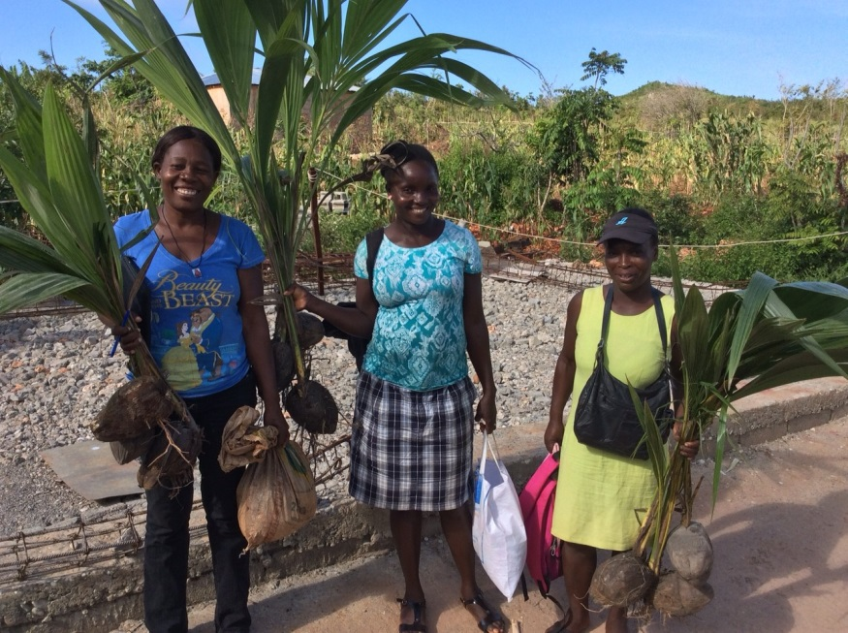
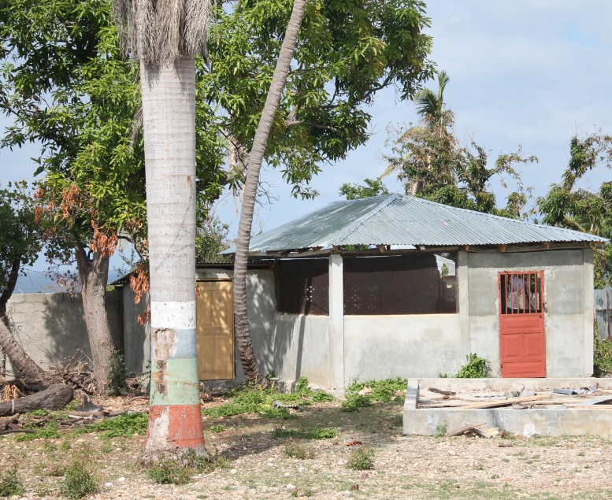
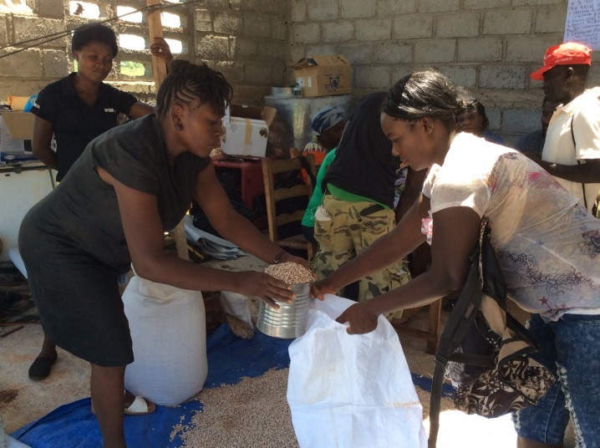
ActionAid distributed food seeds to 742 families in November 2016, in order to catch the winter growing season. This was followed by a distribution to a further 358 families (making 1,100 total) in February for the spring cropping season. A complete training on agro-ecology and a technical support were also provided. ActionAid repaired a local cassava plant which provided livelihoods to 300 local people (mostly women).
Seed distribution in Jeremie, Photo by ActionAid Haiti

Repaired Cassava Mill in Roseaux. Photo by ActionAid Haiti

Women with coconut seedlings. Photo by ActionAid Haiti.

5. Key Achievements
- 1,110 households received agricultural supplies to restart food cropping;
- 300 people, mainly women, restarted livelihood activities through restoration of cassava mill

ActionAid Haiti and ActionAid Ireland thank ElectricAid and its supporters for their generous support for this project.

