

Project Reference No: 16-A-070

PROJECT REPORT

Project Name: Maadili Rabbit Farming Project, Imbaseni Village, Arusha Region - Tanzania.

Organisation Name: Maadili Centre

Date Funds Received: October 2016

Referee: Alfred Brett, Rocklow, Fethard, Co. Tipperary, Ireland (ESB Pensioner)
Rev. Fr. Festus Mangwangi, Catholic Archdiocese of Arusha, P.O. Box
3044, Arusha.

1: Projects Outcomes – the results achieved.

Maadili Rabbits’ Farming Project main objective is to educate the community on commercial rabbit farming as an extension of the promotion of entrepreneurship in agriculture and livestock keeping to women, youths and community/farmers. Also to provide those who were ready with rabbits to help them start their own rabbit farming enterprises.

Electric Aid’s contribution to us to purchase of rabbits, feeds and medicines gave us the opportunity to contribute to the government efforts to promote the importance of using the natural resources in the country especially in the rural areas to start agriculture and livestock keeping enterprises for poverty reduction.

In Tanzania, the consumption of rabbit meat is gradually taking off and more farmers in our region are already enjoying the benefits of this niche business.
PROJECT IMPACT
- Increased awareness and engagement of more people in rabbit farming after acknowledging the advantages in terms of time, space utilisation and profit margin.
- Added on value of some farmers to their livestock keeping enterprises. Some of the farmers that attended our trainings have added rabbit farming to their chicken enterprises.
- The government has commenced promotion of the consumption of rabbit meat in addition to poultry and fish not only because of the health value that it has, but also because of the growing rate of heart disease in Tanzania and related ailments, that has increased awareness of the harmful effects of cholesterol in our diets.
- Increased peoples’ awareness of going for ‘white’ meat which contains low amounts of cholesterol. Unlike ‘red meats’ (especially beef and pork), white meats like ostrich, poultry, fish and rabbit meat contain less fats and cholesterol and have higher health benefits.
- Successfully influenced the establishment of 3 farmers’ association in different regions. In the seminars we also educate the participants about the importance of formation of associations for better marketing of their products.
- Elevated interest of youths in rabbit commercial farming: Our organization also carries seminars for in school youths about guidance, parental education and entrepreneurship. The Maadili Clubs in the secondary schools were established for better implementation of the program in which entrepreneurial education about commercial livestock keeping is provided as options for poverty reduction and income generation.
2: Financial Accountability – how the money was spent.

(Please see the attached worksheet)

3: Project Process Narrative – how the project was implemented or progressed to date.

The money was deposited in our account on October 2016. During the months of November and December 2016 the rabbit cages were built with the help and contributions from Maadili Centre and our community.

Trainings and distribution of rabbits started in January and are ongoing up to date. The distribution is as follows: The participants are given 5 does and 2 bucks and after 4 months they return 10 offspring to the organization, which helps in turn to distribute it to other candidates.

During the month of August we were also invited to attend and provide awareness and education to the participants in the Tanzania Farmer’s Festival in the Arusha region more known as “Nanenane”.

The planned amount of beneficiaries was 240 people in total. After the extension of our services to other regions and the establishment of Maadili Clubs in the schools the number increased. Below is the number of people trained up to date:
Arusha region:
Adult people – 215
Youths – 448 (secondary schools)
Children – 374 (primary schools)

Kilimanjaro region:
Adult people – 197
Youths – 239 (secondary schools)
Children – 211 (primary schools

CHALLENGES:-

- A big challenge is the lack of proper equipment for slaughtering and packing the rabbits’ meat. Because of this most of the farmers have to sell their rabbits alive and at a lower cost to the Rabbit Bliss Company which has the necessary infrastructure. There is need to support the farmers’ associations to stand on their own.

- Some farmers not following the guidance given in the seminars for quality production of rabbits (in regards to cleanliness, feeding and water provision to the mammals). This brings diseases and death of the rabbits.

- Some farmers going against the contract regarding arrangement of rabbits’ distribution.

- Increased demand of rabbits therefore shortage of rabbits to distribute to the people interested in starting the enterprise.

- Some peoples’ negative religious belief regarding rabbits’ meat.

FUTURE PLANS

- To continue to provide the trainings and education through drama and village theatre.
- To produce more newsletters and booklets on livestock keeping.
- To look for support from ElectricAid to purchase small equipment to allow the farmers association to grow by preparing and branding their own products (slaughtering and packing).
- The government authorities gave us permission to carry out the Guidance, Parental Education and Entrepreneurship Program (MALEZI AND MAADILI PROGRAM) in 70 secondary schools in different districts of the Kilimanjaro, Arusha and Dar es Salaam regions. This in order to increase the proportion of youth engagement in agricultural and livestock keeping entrepreneurship.
Up to date we have visited 24 schools and helped to establish the Maadili Clubs in 12 schools. Through the clubs we educate the youths about livestock keeping especially poultry and rabbit farming.

4: Visual Report – photographs.

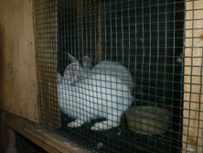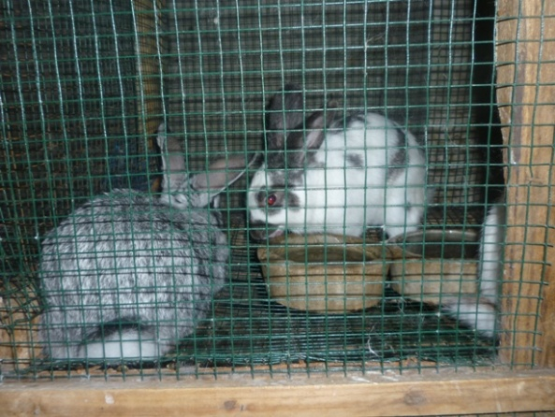

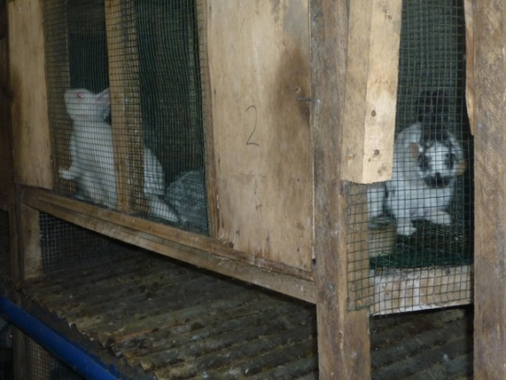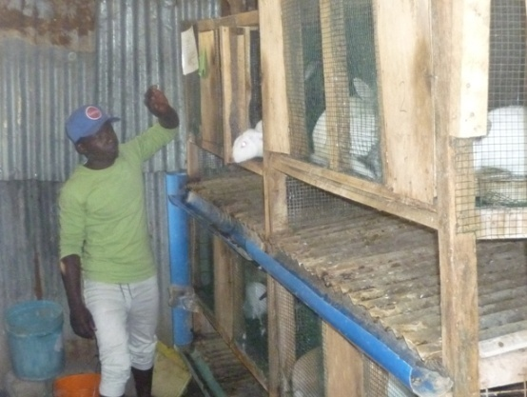

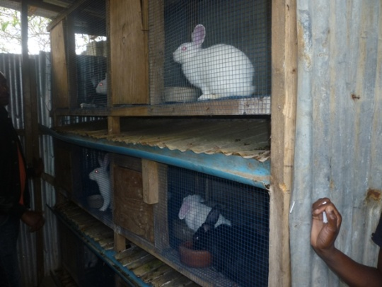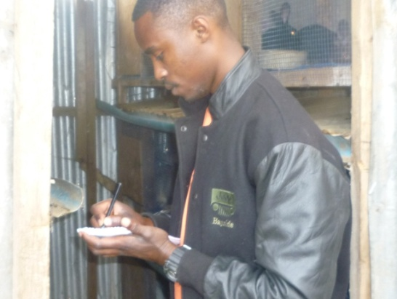

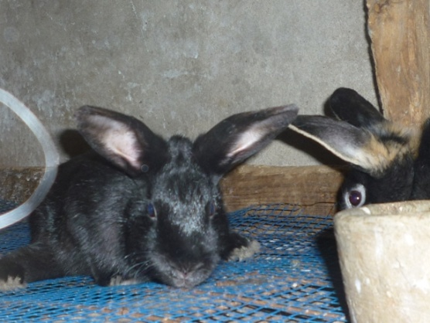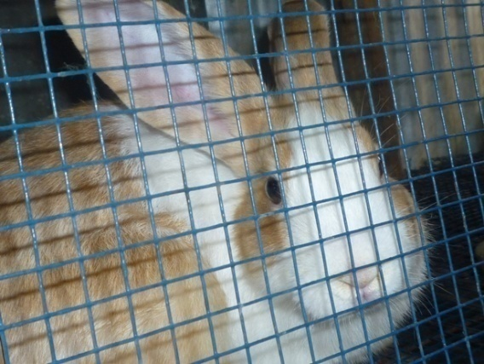

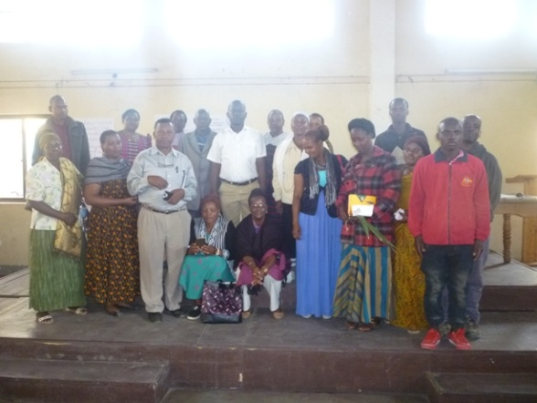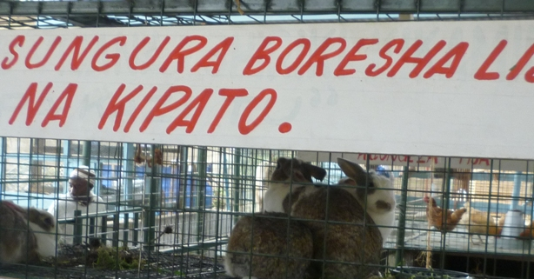

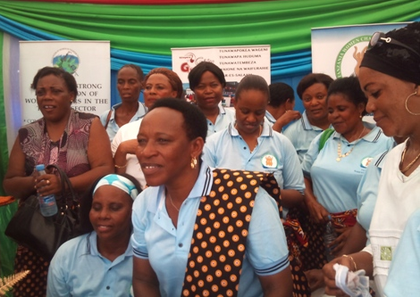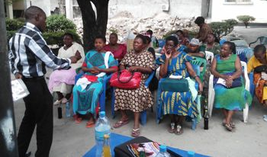

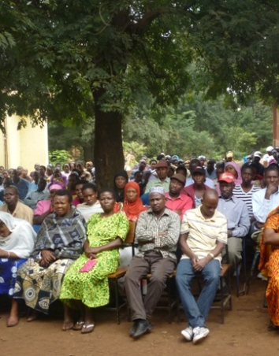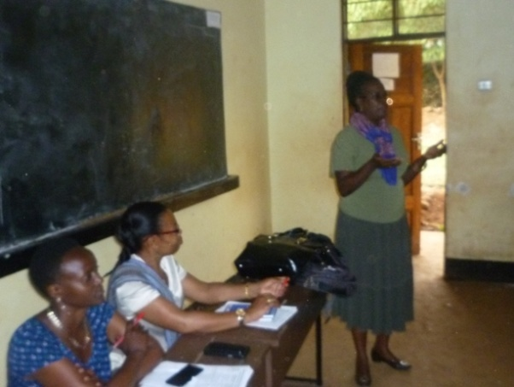

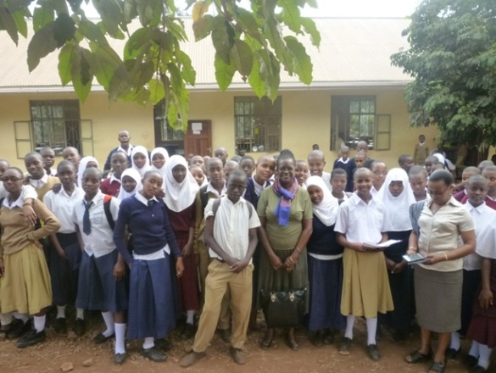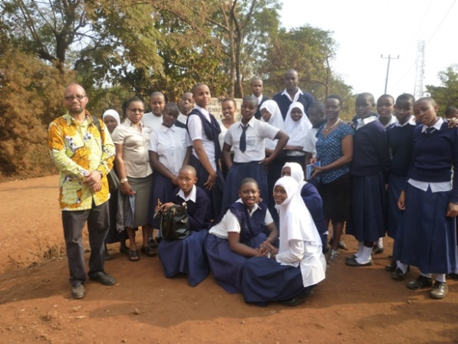

5: Your Comments.

Maadili Centre would like to express our greatest appreciation for the support and interest in our programs that Electric Aid has given us all these years. It has helped to the sustainability of our programs and has enabled us not only to progress gradually due to the lessons learn in each project, but also to get significant recognition from the Tanzanian government.

Our work has been very much appreciated and has been endorsed with the task to spread our work in the primary and secondary schools. Although the government cannot financially support us, we have been given the opportunity to carry out more seminars and produce literature about livestock keeping skills especially for poultry keeping and rabbit farming.

Agriculture and livestock keeping is the backbone of the economy in Tanzania yet, even the farmers lack of knowledge how to raise poultry for business is generally poor and most people who are engaged in business poultry keeping recognize when asked, about their lack of knowledge hence poor achievement in their produce.

We hope that ElectricAid will continue to support us in our efforts to educate the next generation especially the youths and children on the importance of using the resources that we have in our country for the reduction of poverty and increase of the household income. Below we quote a comment from one of the participants of our seminars:

John Lyatuu – Msaranga Secondary School;- ....“I am very grateful for the training received from Maadili Centre about commercial livestock keeping and rabbit farming. When we close school for vacations I shall start this enterprise and help my parents to increase the family income”.

